# 

RAILWAY RESERVATION SYSTEM

**Group Members**:

|  |  |
| --- | --- |
| **NAME** | **ROLL NUMBER** |
| **Allen Kammanghat** | **AM.EN.U4CSE21108** |
| **Durga Lakshmi PC** | **AM.EN.U4CSE21121** |
| **Narayanan PN** | **AM.EN.U4CSE21139** |
| **Pournami P** | **AM.EN.U4CSE21144** |

## Abstract

This project report outlines the development and implementation of a comprehensive Railway Reservation System. The system is designed to simplify and streamline the process of railway reservations, offering powerful features for both administrators and end-users. Developed with Angular for the front-end, Spring Boot for the back-end, and MySQL for the database, the system aims to provide a seamless user experience, ensuring robust connectivity between the database and the front-end application, and allowing for efficient booking processes. Key features include:  
  
• Admin Functionality: Allows for managing trains, specifying seat arrangements, defining pricing structures, and controlling amenities offered on different trains.  
• User Capabilities: Enables users to search for available trains, book tickets, retrieve ticket details by ID, and cancel bookings as needed. Users can also manage their journey details and track their booking status in real time.  
  
This report provides an overview of the system architecture, a breakdown of the core functionalities, integration of backend services, and visual representations of the user interface with key screenshots, offering a comprehensive understanding of the system’s operation.

## Introduction

In today’s fast-paced world, transportation management plays a critical role in ensuring smooth and efficient travel experiences for users. The **Railway Reservation System** is designed to meet this need by providing a user-friendly and functional platform for managing railway reservations. The application is intended to streamline the process of booking tickets, with key functionalities accessible to both administrators responsible for managing train operations and passengers who need to book and manage their tickets.

The system aims to offer an optimized solution that not only enhances user experience through a dynamic and responsive front-end but also ensures secure and efficient backend operations. The project’s main objectives include:

1. **Centralized Platform for Reservation Management:** The system creates a unified platform for administrators to manage trains and users to book tickets efficiently.
2. **Data Integrity and Security:** Ensures robust security measures and data consistency for user details, payment data, and ticket bookings.
3. **User Experience Enhancement:** Provides an intuitive and dynamic interface with real-time data updates, making train bookings convenient for users.

## Contents

1. System Overview  
 o Features  
 o Technologies Used  
2. System Architecture  
 o Component Interaction Diagram  
3. Features Description  
 o Admin Features  
 o User Features  
4. Working of the system  
5. Implementation Details  
 o Backend Code Examples  
 o Database Design  
6. Screenshots  
7. Conclusion  
8. Future Enhancements

## System Overview

Features  
• Admin: Add train details, amenities, and seat arrangements with pricing.  
• User: Search for trains, book tickets, retrieve and cancel tickets by ID.  
  
Technologies Used  
• Front-End: Angular  
• Back-End: Spring Boot  
• Database: MySQL

## System Architecture

The architecture follows an MVC (Model-View-Controller) pattern:  
  
• Model: Represents data structures and database operations.  
• View: User interface created using Angular components.  
• Controller: Handles requests and responses, implemented in Spring Boot.

**Features Description**

**Admin Features**

1. Login authentication for secure access.
2. Add and manage train details, including amenities and pricing.
3. Define seat arrangements for various train classes.
4. Track booking data and manage passenger details.

**User Features**

1. Search for trains using date, source, and destination.
2. Book tickets and view booking details.
3. Retrieve and manage bookings using a unique ticket ID.
4. Cancel tickets and get refund details.

**Working of the System**

The system operates seamlessly by integrating front-end, back-end, and database components:

* **User Interface (UI):** The Angular-based front-end allows users to search for trains, select seats, and confirm bookings. A real-time seat map shows available and booked seats.
* **Backend:** The Spring Boot-based back-end processes all user requests, including ticket bookings, cancellations, and data retrieval.
* **Database Interaction:** MySQL stores information on trains, tickets, and users. Real-time updates ensure data consistency.

**Implementation Details**

* **Backend Code:** Implements APIs for booking, seat management, and data retrieval.
* **Database Design:** Structured tables for trains, passengers, and bookings ensure efficient data handling.

## Screenshots

Place screenshots here:  
  
• Login Page

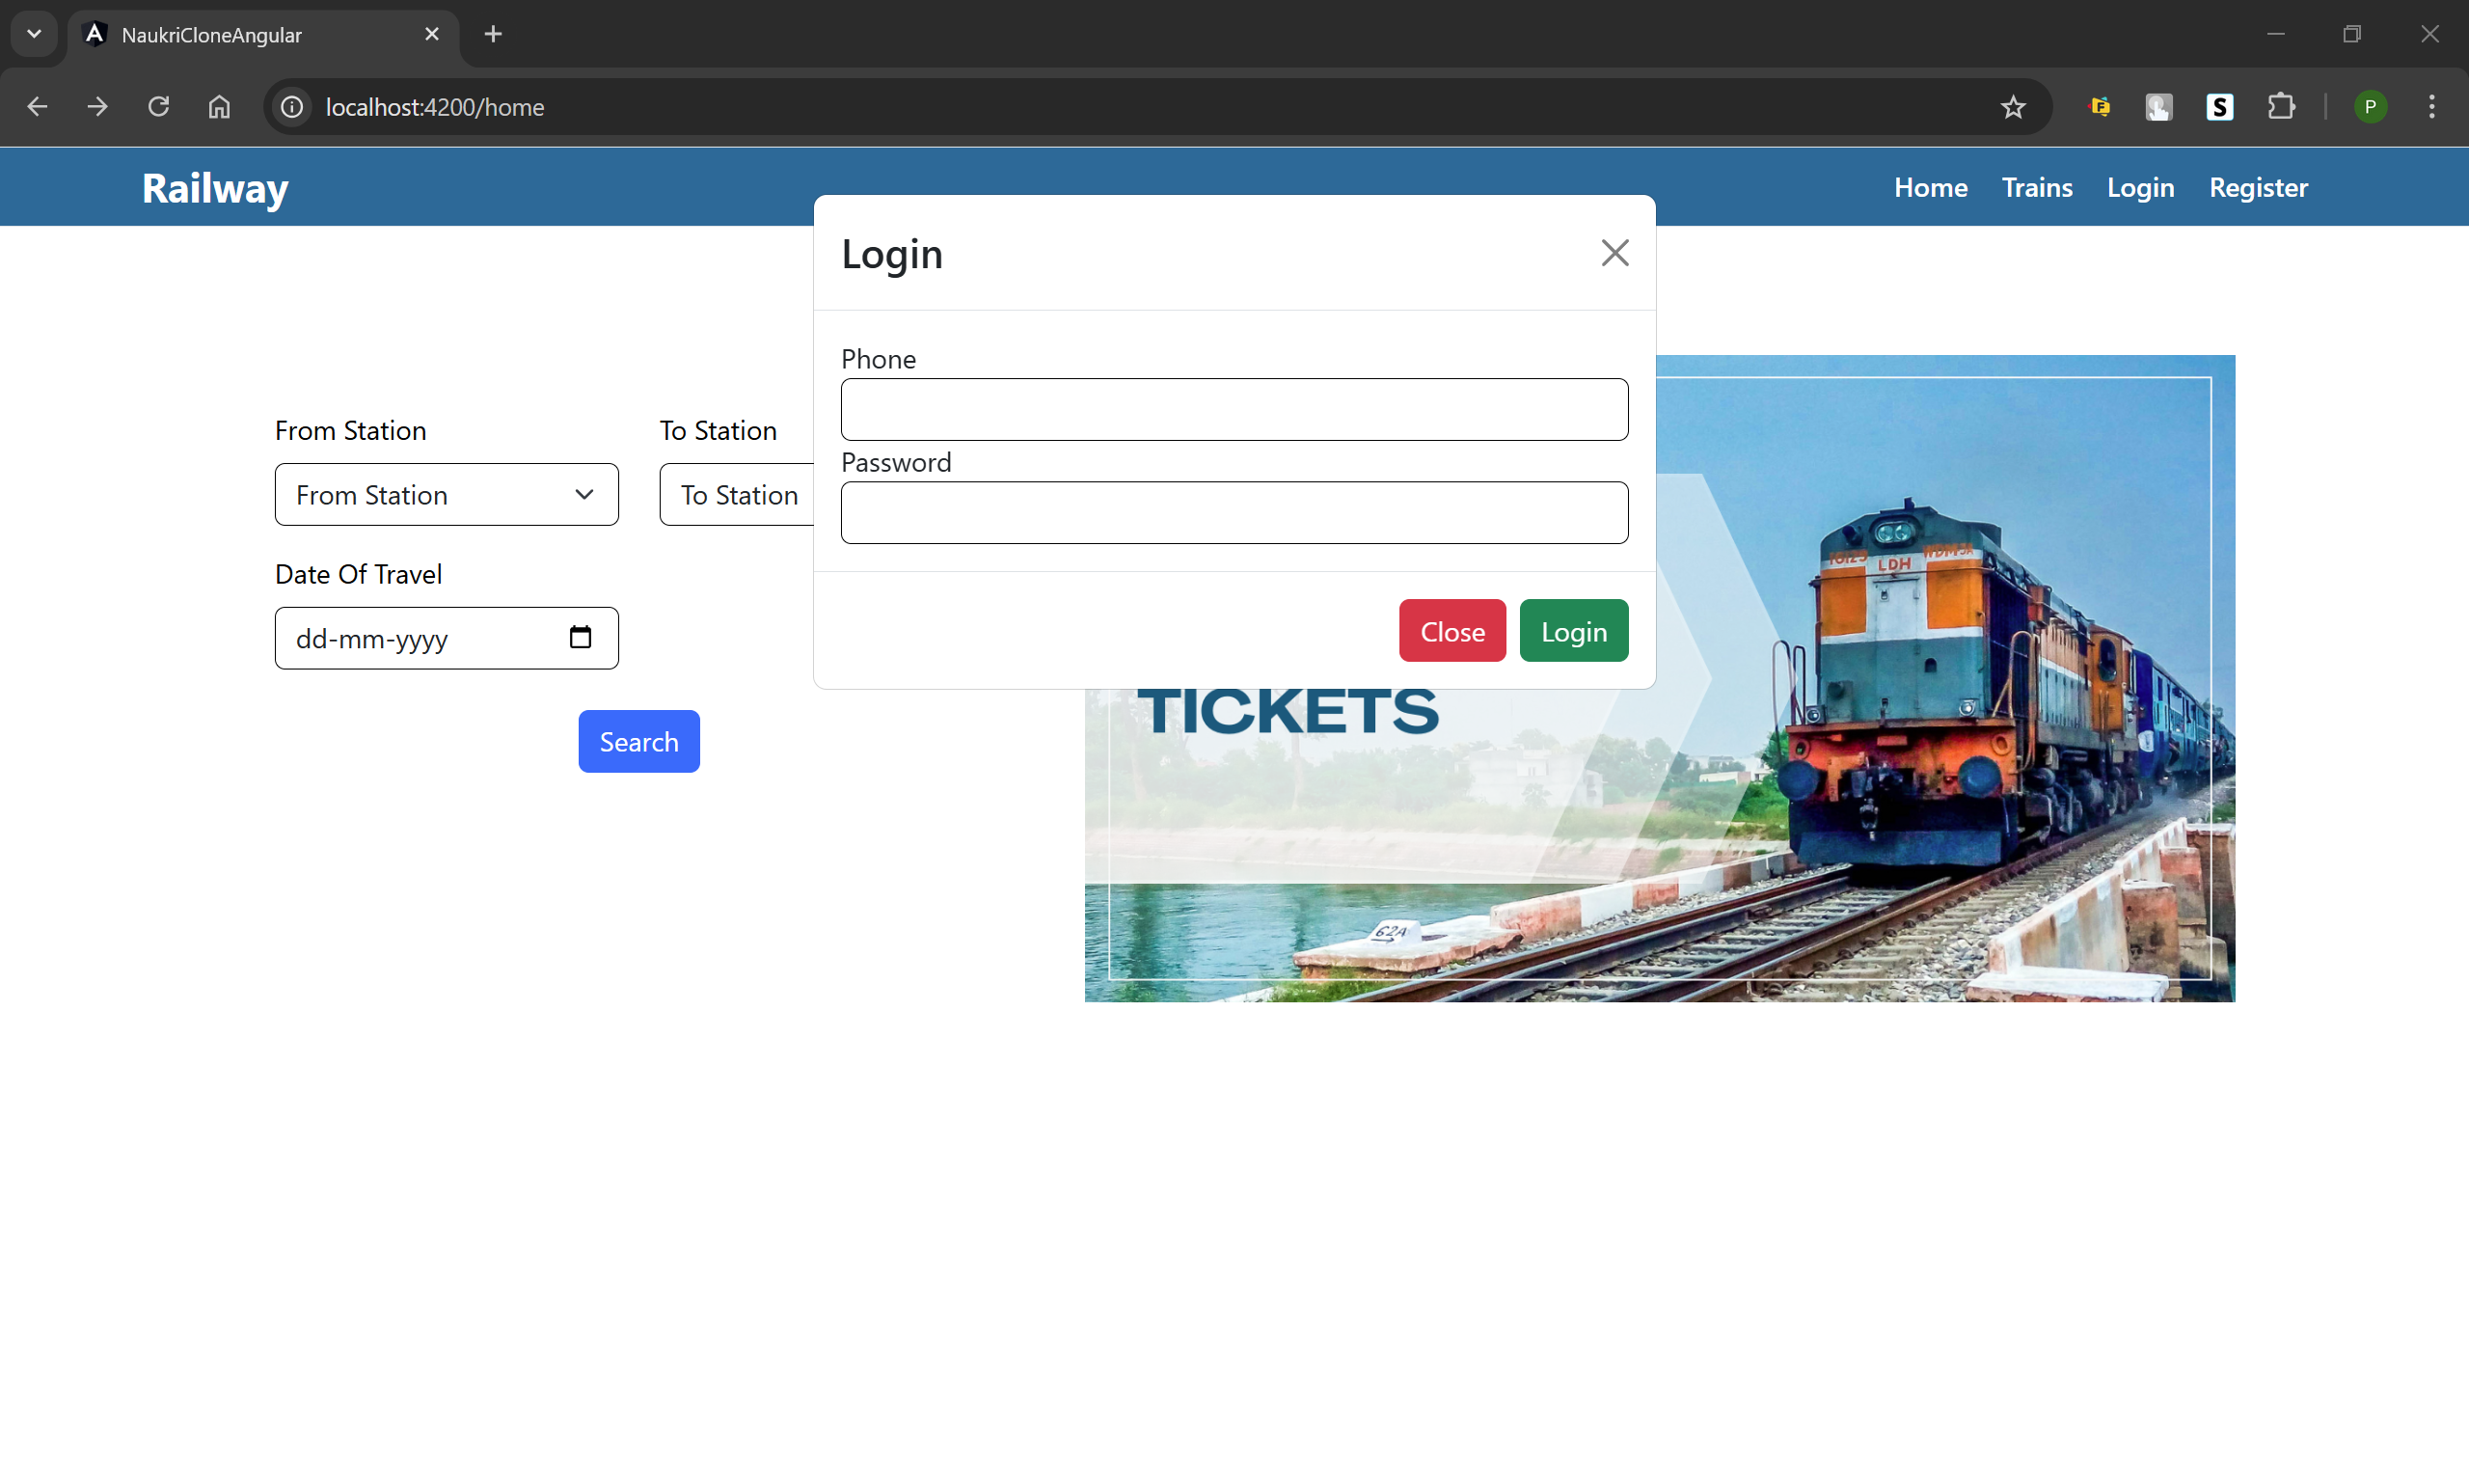

• Home Page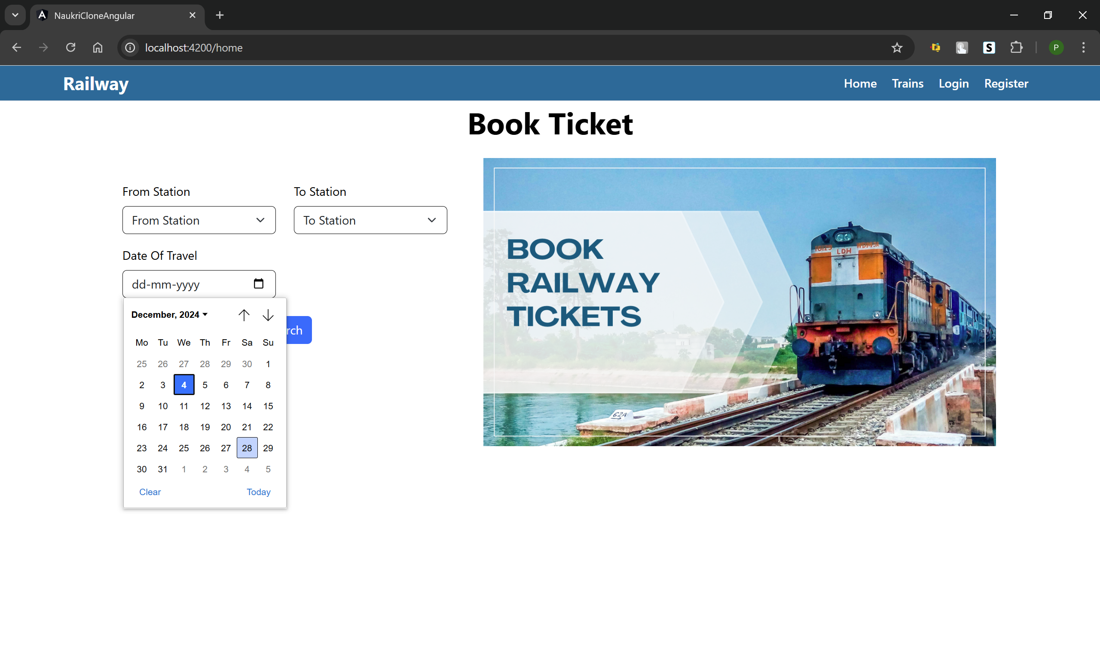

• User Information Page

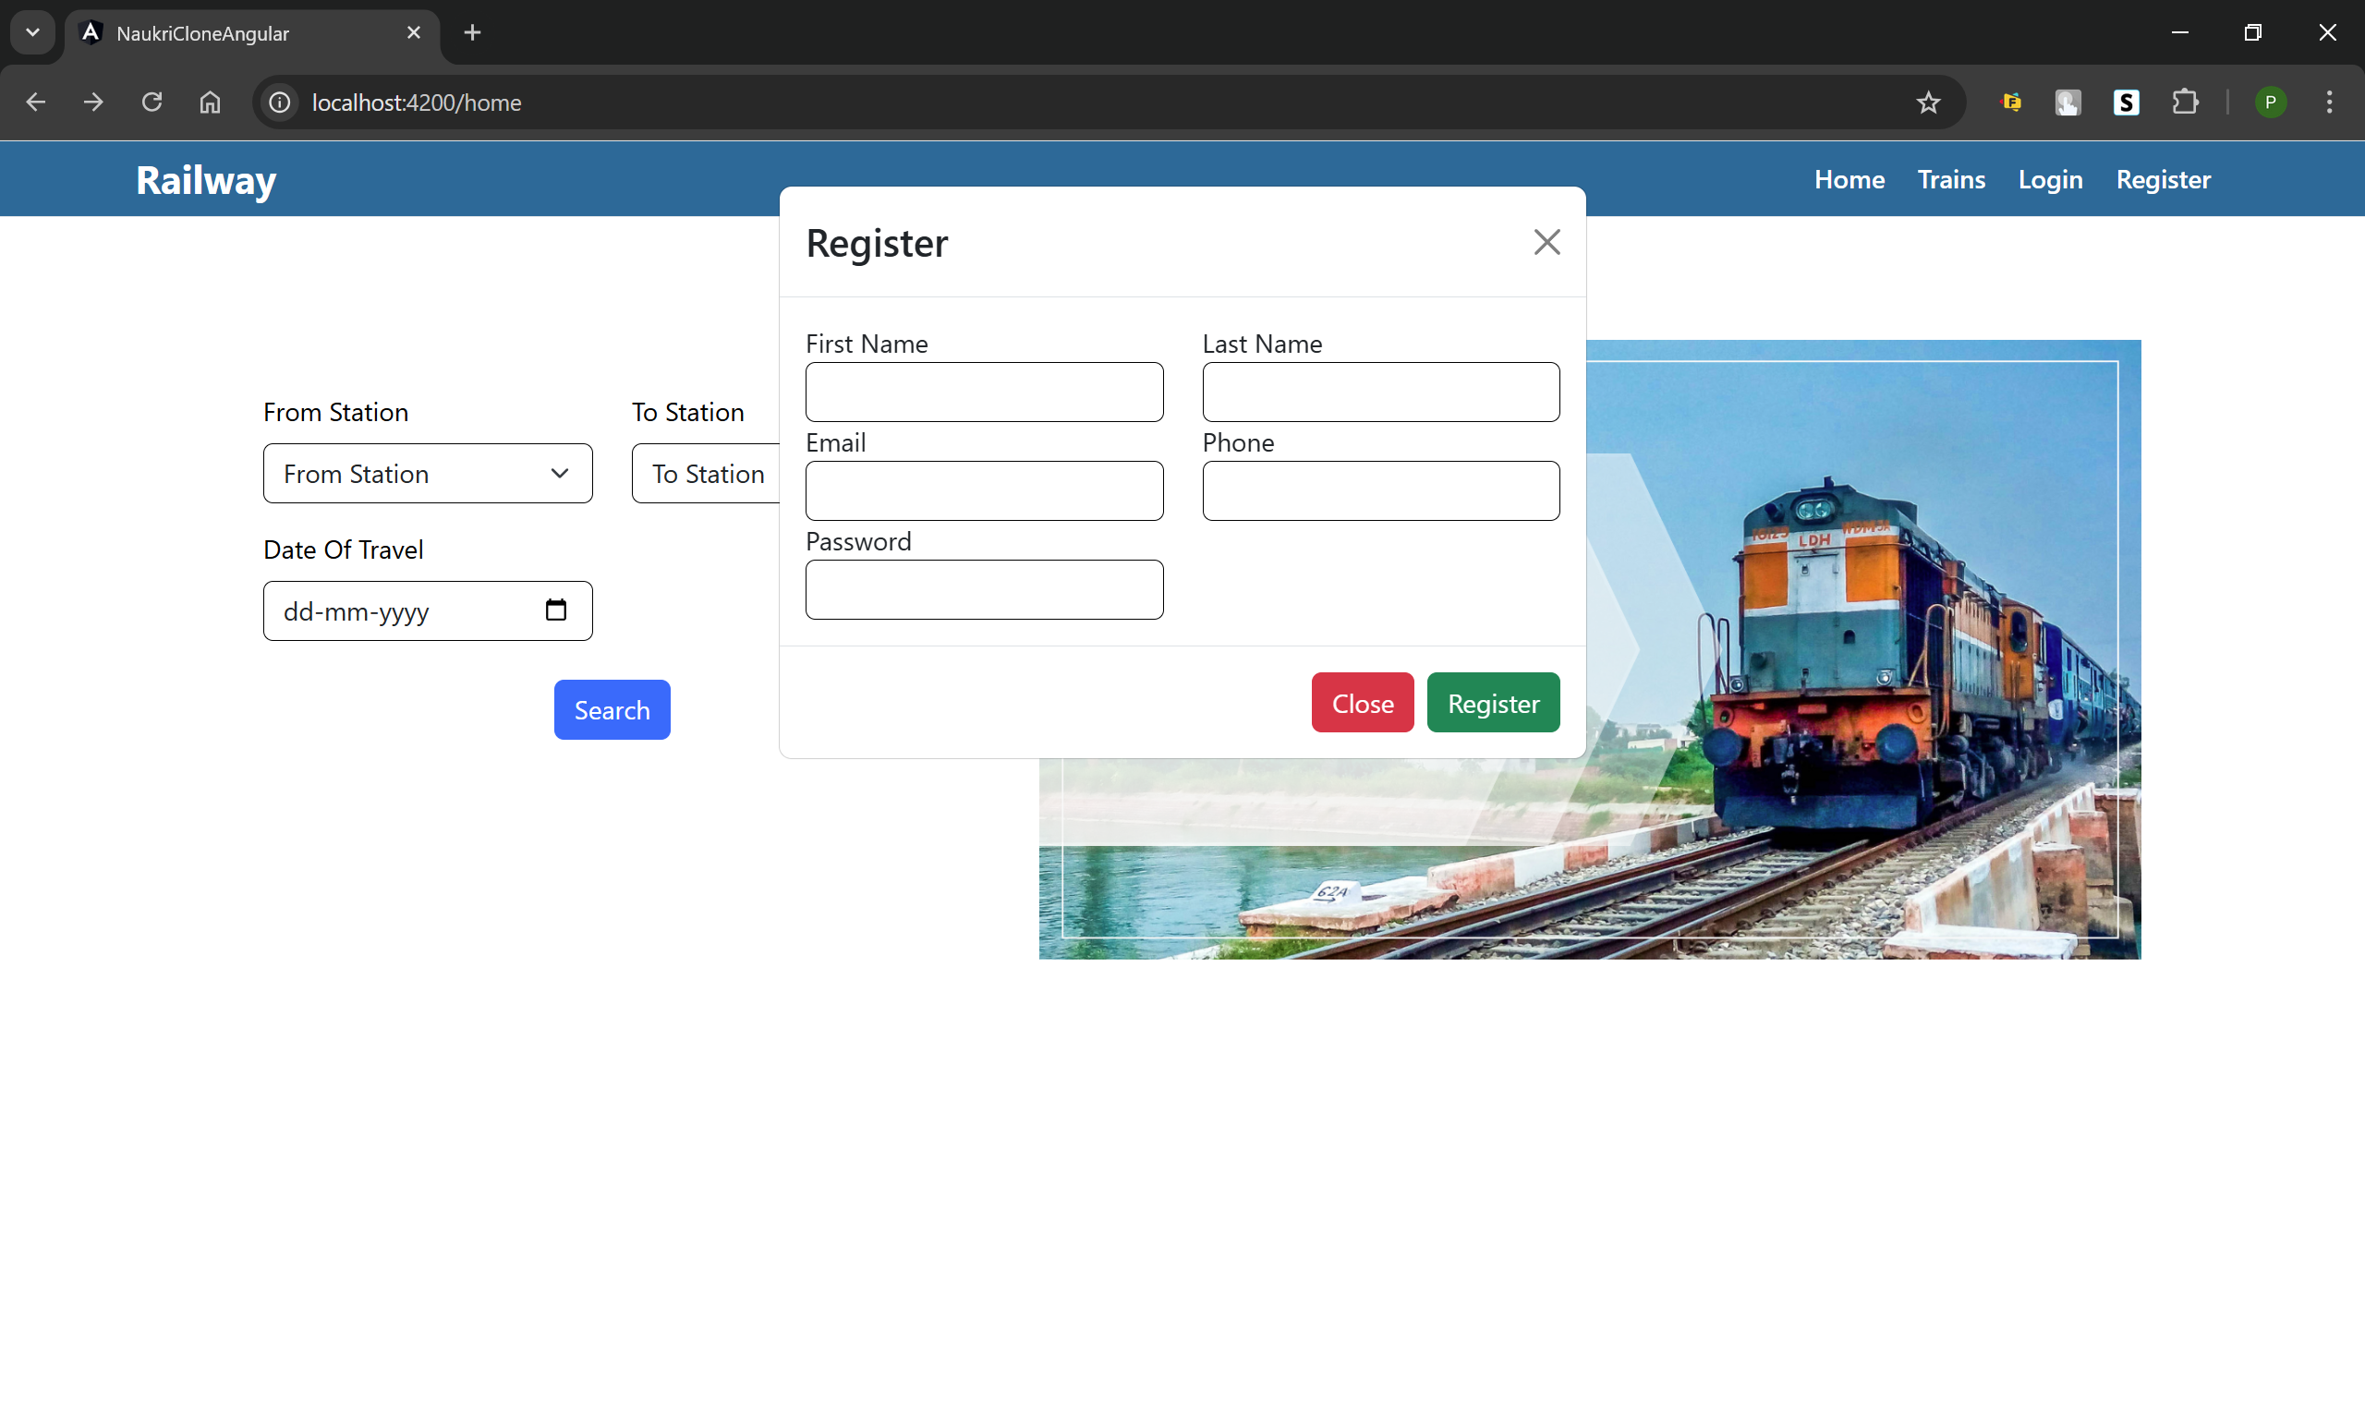

• Train Page

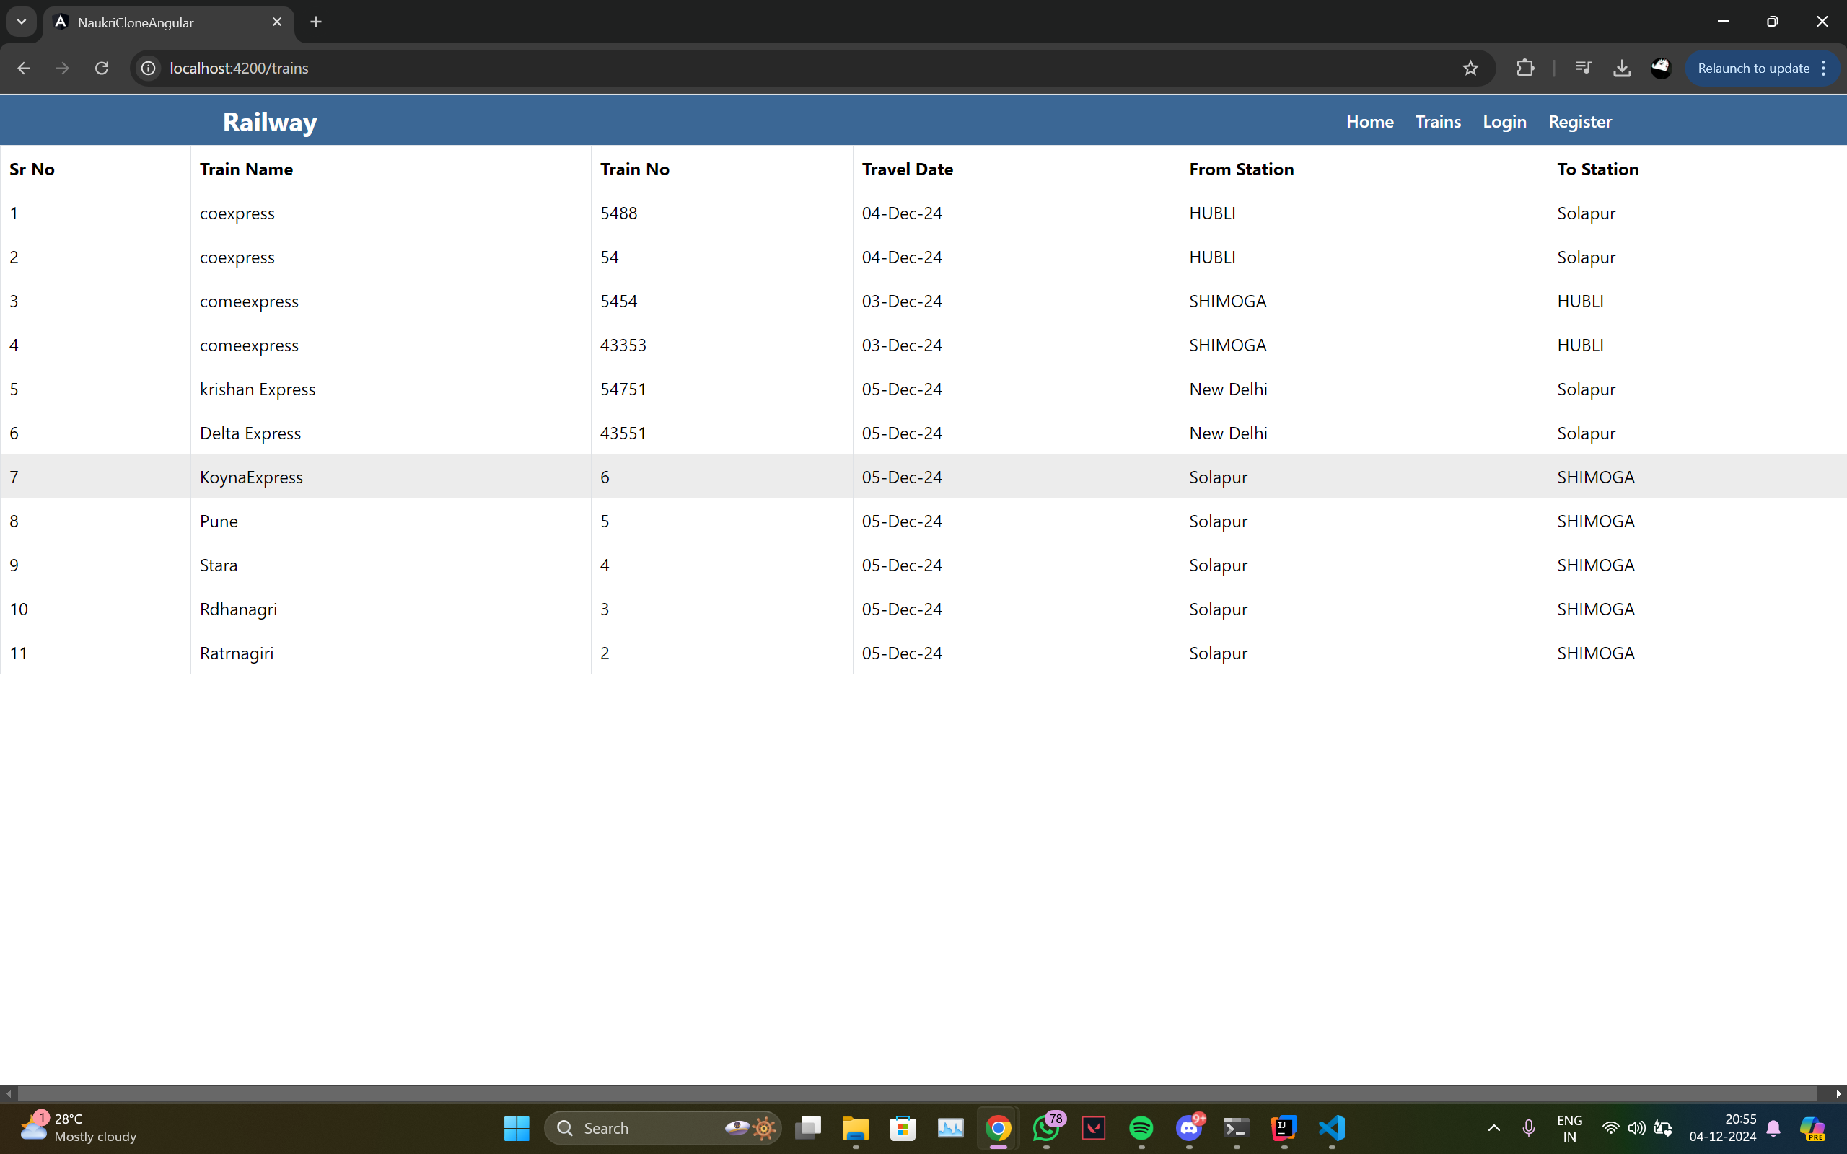

• Booking Options

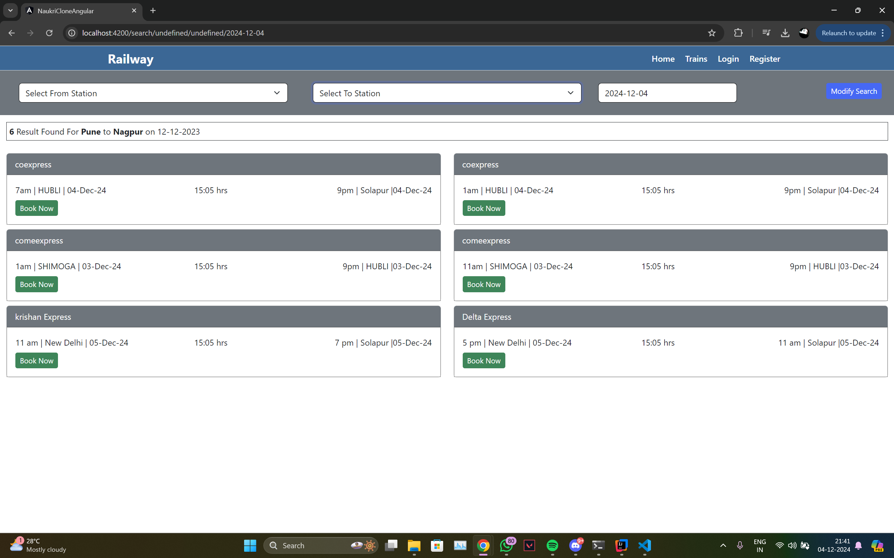  
  
• User Information Page

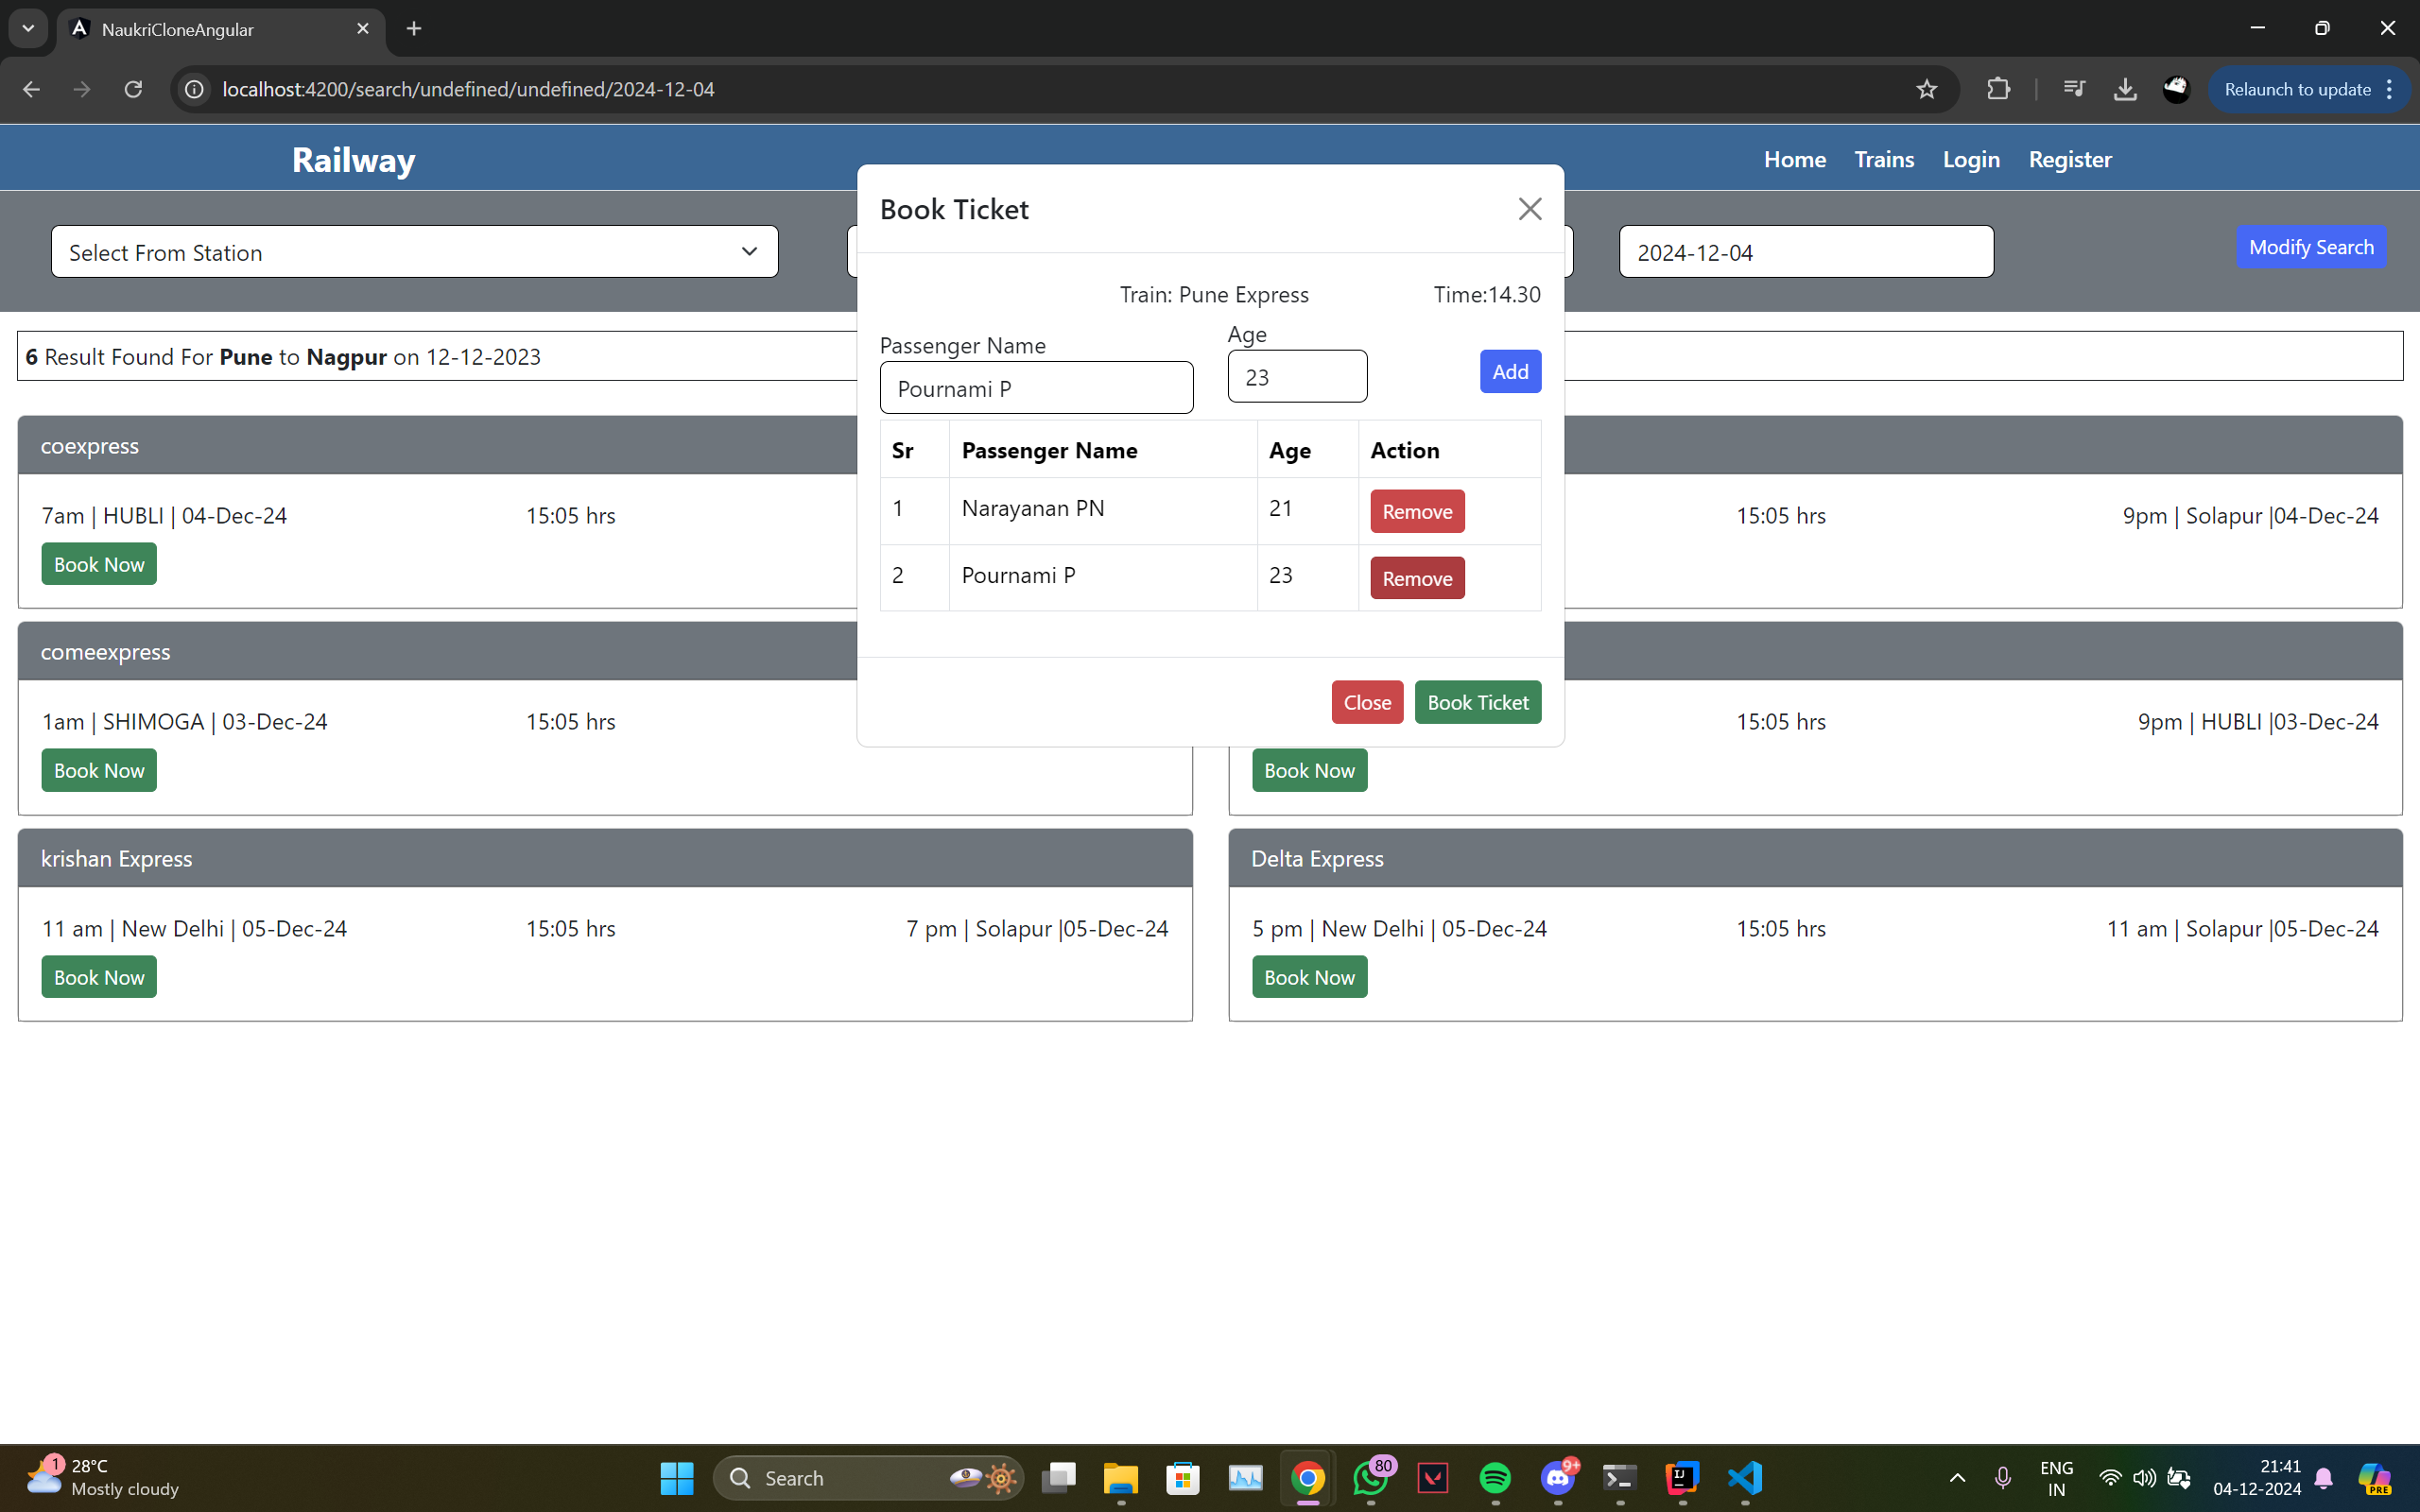

**Future Enhancements**

1. Integration with Payment Gateways: Enable secure online transactions.
2. Real-Time Tracking of Train Locations: Allow users to track train schedules and delays.
3. Push Notifications: Send alerts for ticket updates and reminders.
4. Mobile Application Development: Build a mobile-friendly version of the system.
5. AI-Powered Personalization: Use machine learning for route and booking recommendations.
6. Multi-Language and Multi-Currency Support: Cater to an international user base.
7. Enhanced Reporting for Admins: Provide insights into train operations and bookings.
8. Social Media Integration: Increase visibility through social sharing.

## Conclusion

The Railway Reservation System has been successfully developed and implemented, achieving its primary goal of creating an efficient, user-friendly platform for managing railway reservations. The system ensures that all users—whether administrators or passengers—can interact with a seamless, reliable, and dynamic application.